Achievements and Gaps in Controlling Infection at Health Care Institutions in Saudi Arabia
Student’s Name
Institutional Affiliations

Achievements and Gaps in Controlling Infection at Health Care Institutions in Saudi Arabia
Introduction
Healthcare-associated infections (HAIs) occur in all countries, irrespective of their level of development, and can affect patients, health care workers, and visitors (Assiri et al., 2014). Unfortunately, HAIs usually receive public attention only when there are epidemics (WHO, 2020). As a result, the actual incidence of HAIs is likely to be underestimated, especially in cases where the patient’s stay in hospital is shorter than the incubation period of the infecting microorganism (a developing infection), and symptoms may therefore not present until days after the patient is discharged (Assiri et al., 2014). Locally, the Saudi Arabian Ministry of Health has achieved some milestones in the control of HAIs, even though the infrastructure for infection control programs in Saudi Arabian hospitals remains underdeveloped (Kritsotakis et al, 2017). Nonetheless, certain recommendations and activities can be implemented to reduce the prevalence of these infections, which can sometimes spread to society and create a pandemic situation that may be difficult to manage.
Aims and Objectives of this Paper
This paper aims to use relevant literature to compare previous trends in the prevalence of HAIs in Saudi Arabia to assess the achievements of the Ministry of Health in attempting to control HAIs. The paper also aims at offering current trends, and objective analysis of the gaps in the attempt to control HAIs in Saudi Arabia. The last objective is to offer recommended activities and procedures that can seal these gaps and therefore reduce HAI prevalence in Saudi Arabia.
Literature Review
Previous Trends
In order to assess the achievements in Saudi Arabia over the years in control of HAIs, two main aspects of the fight against HAI can be compared in previous times and the current situation. First is the prevalence of HAIs over the years and the other is the degree of understanding of safety procedures and infection control among health care professionals as this affects how they deal with the infections.
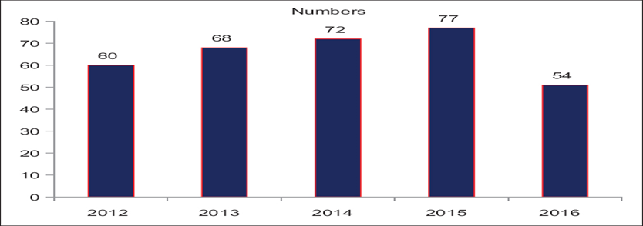
Figure 1: Graph by Gupta et al. (2017)
In Gupta et al. (2017), a retrospective study carried out by the Infection Prevention and Control Department of the Al Rass General Hospital was used to estimate that healthcare-associated infection was in an increasing trend from 2012-2015, with somewhat downtrends reported in 2016 where only 54 cases were reported, thus indicating a slightly decreasing trend for the first time in the previous 5 years. This decrease reflects positively on the efforts of the Ministry of Health. Regarding the fatality of HCAIs in Saudi Arabia as of 2014, Tawfiq et al. (2014) conducted a study that found a fatality rate reported in the range of 2.3 to 14.4%, giving an average of 8.2 %. Also, a 2003 study by Ballkhy et al. (2003) estimated the total HAI prevalence at about 8% at the time. A comparison of this percentage with that of recent times below would reveal a general increase in hospital-acquired infections over the years. Regarding health care professional awareness of safety procedures (SP) and infection control, a past study by Maqbool (2003) found that a relatively low level of awareness of SP has been reported among health care professionals. These numbers can be used to compare the current trends of HAI prevalence in Saudi Arabia and therefore try to understand the achievements of the Ministry of Health.
The Current Situation
The most recent study on the prevalence of HAIs in Middle Eastern countries of the Arab League, consisting of Egypt, Kingdom of Saudi Arabia (SA), United Arab Emirates (UAE), Lebanon, Oman, Kuwait, and Bahrain, was done by Alothman et al. (2020) and some of its findings are illustrated in the graph below. The graph uses data from a number of public hospitals in these countries using the European Center for Disease Control and Prevention (ECDC) standardized protocol for a combined PPS on HAIs and anti-microbial use. This was, however, before the Covid-19 pandemic that has led to an unprecedented spike in Hospital Acquired Infection prevalence and fatality.
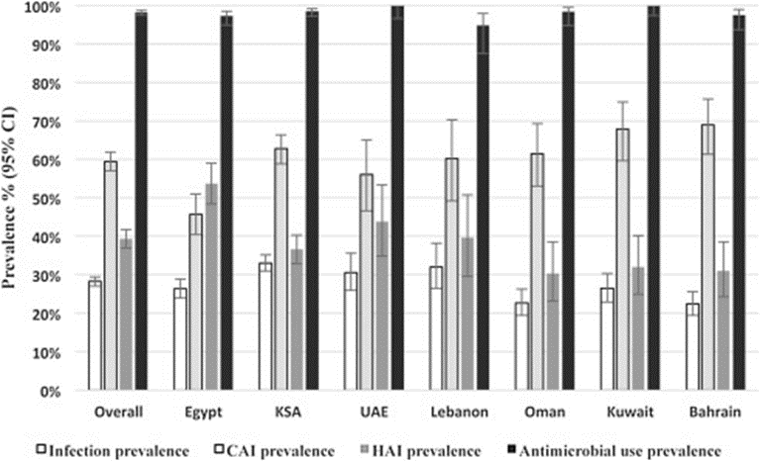
Figure 2: Image by Alothman et al. (2020)
In Saudi Arabia (KSA), hospital-acquired infection prevalence accounted for about 35 per cent of the total infections (Alothman et al., 2020). However, such prevalence is subject to changes in population over the years and the discovery of more HIAs. Enani et al. (2019) used a retrospective observational study in three private hospitals to arrive at an estimated 3.5% as the proportion of infections that were hospital-acquired. This can be used to imply that private hospitals are better at HAI management compared to public hospitals. Regarding the knowledge of SP and IC by health care workers, a study in Saudi Arabia by Hamid et al. (2019) reported excellent knowledge of hand hygiene as part of measures aimed at controlling HAI spread. This increased awareness among healthcare workers can be regarded as an achievement, as it implies more readiness among the healthcare workforce to deal with HAIs due to a better understanding of the ways to deal with the spread of HIAs.
Nonetheless, one of the main achievements of the Ministry of Health in Saudi Arabia was the strengthening of health security during Hajj gatherings by increasing surveillance through the use of the international health regulations (IHRs) public health core capacity assessment at the points of entry and disseminated the updated pre-travel advice and health requirements for pilgrims and workers involved in the Hajj (Badriah et al., 2017). Furthermore, Badriah et al. (2017) explain the clearly outlined reporting pathway for any diseases to the authorities in case of an outbreak, which allows the surveillance teams to investigate any infectious diseases and propose measures of dealing with them as soon as possible. This system also incorporates electronic, pilgrim-level, and health level symptom surveillance. This has enhanced the readiness of the ministry to deal with any epidemic, especially if it arises during Hajj gatherings.
The Observed Gaps
The gaps present in the attempt to control HAIs in Saudi Arabia are mainly evident on two fronts. First, there is a degree of inadequacy on the part of the medical professionals, mainly from a lack of proper information concerning HAIs and their management, and professional negligence when it comes to practices that help reduce HAI prevalence. A recent questionnaire administered by Lolowah et al. (2017 ) as part of methods to determine knowledge of Standard Precautions and Infection control among Saudi Arabian health care professionals in Al-Ahsa found a considerable lack of knowledge in the belief that the use of PPE completely eliminates the risk of new infections, that PPE use is exclusively for laboratory and cleaning staﬀ, and the manner in which PPEs are to be disposed off (51.2%, 60.7% and 37.3% incorrect responses respectively). Additionally, John et al. (2017) revealed an insufficiency of infection control training in medical schools, with Saudi Arabian medical students being reported to have little access to hospitals in their second and third years where they are taught about infection control.
Secondly, the public makes the attempts more difficult, especially during the Hajj and Umra mass gatherings. Despite the Saudi Arabian Ministry of Health’s attempts to strategically increase surveillance during Hajj gatherings by establishing a reporting pathway, a sample potential incidence of MERS-CoV virus incidence during Hajj (shown below) by Lessler et al. (2014) illustrates that the control of infection can be extremely complicated in mass gatherings.
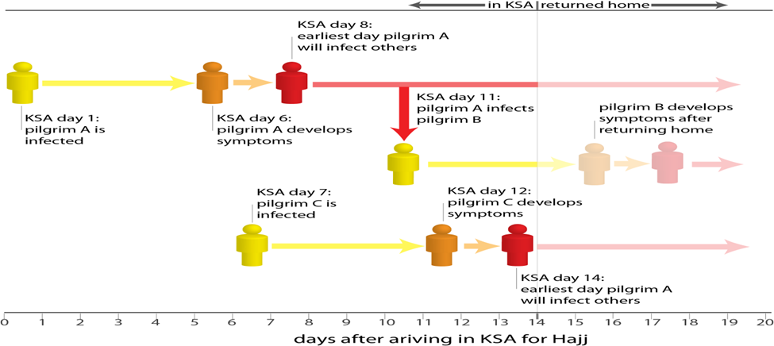
Figure 3: Image by Lessler et al. (2014)
In the case of a highly contagious infection such as MERS-CoV, it can be predicted that the resulting infections will overwhelm the health care facilities due to the high number of infections that occur at any one time. Such public gatherings are, therefore, a huge risk factor that may slow down the efforts to promote public health. Additionally, the lack of public awareness of HAIs implies that they do not understand their role in the fight against HAI prevalence.
Recommended Activities and Tasks to be Implemented
In response to the gaps diminishing control efforts of HAIs in Saudi Arabia, further measures can be implemented to make this process more effective. During pilgrimages in Saudi Arabia, a study conducted by Ghabrah et al. (2007) observed that in order to enhance prevention of RTIs, it is important to encourage personal hygiene, cough etiquette, and hand hygiene among pilgrims. Collins (2008) proposes several practices that can be done by health care facility staff, such as maintaining the cleanliness of the hospital environment to minimize surface contamination, use of the appropriate chemicals to counter resistant bacteria and proper use of Personal Protective Equipment (PPE) such as gloves. Furthermore, he adds the importance of an effective leadership system in the health care facility which would ensure that institution administrators, directors, and individual practitioners take responsibility in reducing the risk of infections, with the engagement of nursing leaders to collaborate with coworkers and hospital administrators in safety, teamwork and communication strategies are critical requirements to improve safe and reliable care. Moreover, he recommends that that teaching and training must be strengthened through the use of evidenced-based knowledge reform and training to fulfill the health care facilities’ staff knowledge deficiencies related to Infection Control and Standard Procedures to protect nursing staff and their patients (Collins, 2008). Finally, more public awareness should be created on how they can help curb the spread of HAIs.
Conclusion
In conclusion, the previous trends show a deficit of knowledge of infection control among health care workers in Saudi Arabia in the past, which compared to current trends show one achievement of the Saudi Arabian Ministry of Health in educating the professionals. Furthermore, the prevalence of HAIs in Saudi Arabia showed a slight decrease, which can be seen as progress. Nonetheless, further measures and activities can be done on the part of the public and health care workers to reduce the prevalence of HAIs in Saudi Arabia, and as a result, improve general public health.

References
Alothman, A., Adel, A., Ramy, K., Yasser, G., et al. (2020). Prevalence in infection and anti-microbial use in the acute-care hospital setting in the Middle East: Results from the first point prevalence survey in the region. International Journal of Infectious Diseases. 101, p249-258. Retrieved from https://www.ijidonline.com/article/S1201-9712(20)32198-6/fulltext#secsect0005
Al-Tawfiq, J., & Tambyah, P. (2014). Healthcare associated infections (HAI) perspectives. J Infect Public Health 7:339-44. Retrieved from https://pubmed.ncbi.nlm.nih.gov/24861643/
Assiri, A., Choudhry, A., Alsaleh, S., Alanazi, K., & Alsaleh, S. (2014). Evaluation of Infection Prevention and Control Programmes (IPC), and Assessment Tools for IPC-Programmes at MOH-Health Facilities in Saudi Arabia. Open Journal of Nursing. 4, 483-492. doi: 10.4236/ojn.2014.47051.
Badriah, M., Alotaibi, H., Saber, Y., Abdul-Aziz, A., Bin Saeed, Abdulhafeez, T., Amnah, H., Alawam, M., Kingsley, L. (2015). Strengthening health security at the Hajj mass gatherings: characteristics of the infectious diseases surveillance systems operational during the 2015 Hajj, Journal of Travel Medicine, Volume 24, Issue 3. Retrieved from https://doi.org/10.1093/jtm/taw087
Balkhy, H., Cunningham, G., Chew, F., et al (2006). Hospital- and Community-acquired infections: a point prevalence and risk factors survey in a tertiary care center in Saudi Arabia. International Journal of Infectious Diseases. 10, 4, p 326-333. Retrieved from https://www.ijidonline.com/article/S1201-9712(06)00016-6/fulltext#secd9305910e1843
Collins, A. (2008). Preventing Health Care-Associated Infections. Patient Safety and Quality: An Evidence-Based Handbook for Nurses. Chapter 41. Retrieved from https://www.ncbi.nlm.nih.gov/books/NBK2683/
Enani, M., Alzahrani, R., Alzubaidy, K., Ajjaj, R., & Saeed, A. (2019). THE PREVALENCE AND CHARACTERS OF HOSPITAL ACQUIRED INFECTIONS IN THREE PRIVATE HOSPITAL, JEDDAH, SAUDI ARABIA. International Journal of Advanced Research. 7. 1262-1269. 10.21474/IJAR01/9952. Retrieved from https://www.journalijar.com/article/29865/the-prevalence-and-characters--of-hospital-acquired-infections-in-three-private-hospital,-jeddah,-saudi-arabia/
Ghabrah, M., Madani, T., Albarrak, A., Alhazmi, M., Alazraqi, T., Alhudaithi, M., & Ishaq AH. (2007). Assessment of infection control knowledge, attitude and practice among healthcare workers during the Hajj period of the Islamic year 1423. Scand J Infect Dis. ;39(11-12):1018-24. doi: 10.1080/00365540701466173 Retrieved from https://pubmed.ncbi.nlm.nih.gov/17852933/
Gupta Sanjay Kumar, Al Khaleefah Fahd Khaleefah, Al Harbi Ibrahim Saifi. (2017). An epidemiological study of health-care-associated infections and their anti-microbial sensitivity pattern in the Al-Qassim region of Kingdom of Saudi Arabia. Community Acquired Infection. 4, 3, p45-50. Retrieved from https://www.caijournal.com/citation.asp?issn=2225-6482;year=2017;volume=4;issue=3;spage=45;epage=50;aulast=Gupta;aid=CommunityAcquirInfect_2017_4_3_45_240007
Hamid, H., Mustafa, M., Al-Rasheedi, M., Balkhi, B., Suliman, N., Alshaafee, W., & Mohammed, A. (2019) Assessment of hospital staff knowledge, attitudes and practices (KAPS) on activities related to prevention and control of hospital acquired infections. J Infect Prev. doi 10.5923/j.ijpt.20190801.01.
John, A., Tomas, M., & Hari A., et al. (2017). Do medical students receive training in correct use of personal protective equipment? Med Educ Online.22:1264125. 10.1080/10872981.2017.1264125.
Kritsotakis, E., Kontopidou, F., Astrinaki, E., Roumbelaki, M., Ioan-nidou, E., & Gikas, A. (2017) Prevalence, incidence burden, and clinical impact of healthcare-associated infections and anti-microbial resistance: a national prevalent cohort study in acute care hospitals in Greece. Infect Drug Resist.10:317–328.
Lessler, J., Rodriguez-Barraquer, I., Cummings, D., Garske, T., Van Kerkhove, M., Mills, H., Truelove, S., Hakeem, R., Albarrak, A., & Ferguson, M. (2014). The MERS-CoV Scenario Modeling Working Group -. Estimating Potential Incidence of MERS-CoV Associated with Hajj Pilgrims to Saudi Arabia, 2014. PLOS Currents Outbreaks. Edition 1. doi: 10.1371/currents.outbreaks.c5c9c9abd636164a9b6fd4dbda974369.
Lolowah, A., Quadri, S., Al-Braheem, N., Albisher, N., Al-Suroj, H., Al-Drees, S., Al-Hammar, A., & Ibrahim, S. (2017). Knowledge of Standard Precautions among Healthcare Professionals in Saudi Arabia: Need for filling the gaps. International Journal of Scientific Research. 6. Retrieved from https://www.researchgate.net/publication/315892333_Knowledge_of_Standard_Precautions_among_Healthcare_Professionals_in_Saudi_Arabia_Need_for_filling_the_gaps
Maqbool A. (2002). Knowledge, attitude and practices among healthcare workers on needle-
stick injuries. Ann Saudi Med.22: 396-9. Retrieved from https://www.researchgate.net/publication/6653390_Knowledge_Attitude_and_Practices_Among_Health_Care_Workers_on_Needle-Stick_Injuries
WHO Health Care Associated Infections FACT SHEET. (2020). Retrieved from https://www.who.int/gpsc/country_work/gpsc_ccisc_fact_sheet_en.pdf

